# **Microsoft Project Features You Need to Use**

Since its launch, Microsoft Project has helped project managers track progress, assign tasks, manage resources, and perform other similar tasks. Originally released as a web-based application but soon adapted for PC use, Microsoft Project features specifically designed tools to help you work on various projects from scratch. It includes support for the stages of project planning, resource collection and development, budget setting and analysing, and project tracking.

[Learn how you can use Microsoft Project as part of your business offering and get more sales.](https://info.sherweb.com/o365-how-microsoft-project-can-help-you-become-more-profitable.html)

**7 Most Important Microsoft Project Features**

There are lots of useful Microsoft Project features that help you work more productively. Let’s take a closer look at some of them.

**1) Planning and Scheduling**

Planning and scheduling arguably constitute the most important stage of project management. They form the backbone of the entire project and can either make or break the whole thing.

What does this stage entail? For starters, it specifies how and when each task should be completed. Then, these tasks are assigned to various team members and allocated any necessary resources. This makes the entire process smooth and transparent, with everyone aware of their duties and responsibilities. This is precisely what Microsoft Project is good at. It utilizes the following to ensure accurate project management:

• **Prioritization:** Helps you prioritize your project’s tasks, eliminating surprises and allowing your team to focus on addressing the most important matters first.

• **Task management:** Allows project managers to define the activities involved in the project and decide how they should be assigned to different members.

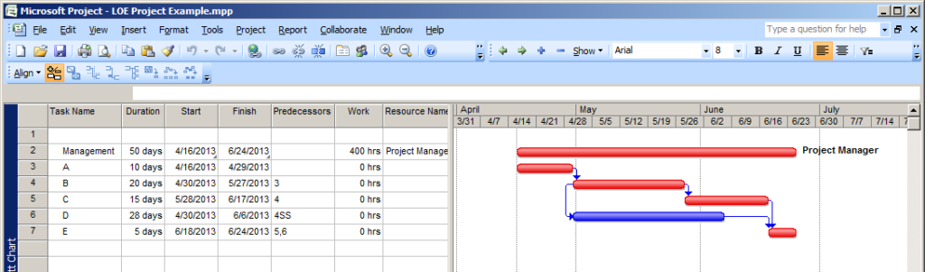  
• **Team calendar:** Having a shared team calendar is a real blessing, as it ensures that all team members are on the same page at all times. Your team members will get notifications for upcoming meetings and events and be able to synchronize their work schedules for more efficient workflow.

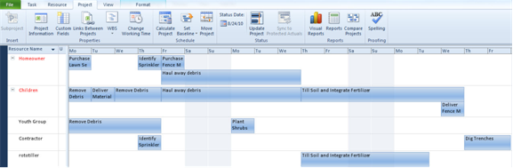

**2) Project Timeline View**

This is one of the best features of Microsoft Project. When you are working on a project, you obviously want to have everything in one place and keep all schedules synced. But what happens when you need someone independent of the project team to track your progress and check on how you’re doing?

The answer lies in Microsoft Project’s timeline view. This beautifully presents the whole project with a top-down view of the entire work. For instance, if you plan to present the project to your stakeholders, management, or partners, you can easily preview what they would see from their perspective using the project timeline view.

How can you add value to the timeline view? For starters, you can make some formatting changes. The colours of project phases can be changed, tasks can be aligned, and various other formats can be adjusted. The process is rather simple. All you have to do to add something to your timeline is right-click on the task and select the option to add it. You can modify the formatting to fit an e-mail, presentation, and so on.

**3) Collaboration**

Collaboration is an essential part of any project. Each activity involves lots of people, so you’d ideally like to connect all of them together on a common platform so you can easily share information with each other. How is collaboration achieved in all of this? Let’s find out.

• **File sharing:** Microsoft Project allows you to share files with other members of your team. This helps you ensure all members have any relevant documentation so they can work on the project with minimal interruptions.

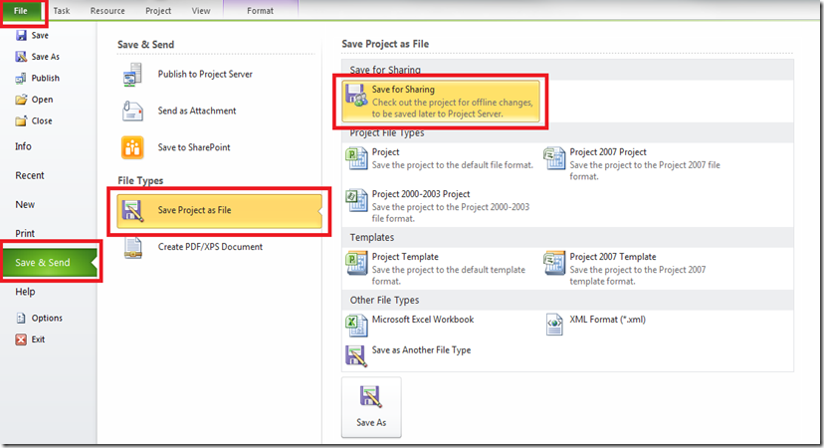

• **Team dashboard:** A team dashboard is crucial, as it offers an overview of the most important information and statistics relevant to your project. With the help of this Microsoft Project feature, you can actually add multiple graphs, charts, data presentations, and other graphics. This will help make your work more organized, lively, and visual. It also helps with team allocation and resource management. The dashboard is particularly useful during meetings and presentations, as it essentially serves as a project KPI report.

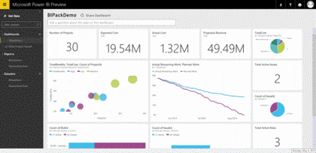

• **Sharing client data:** Often, simply managing your own information is not sufficient for a project’s success. You also need to work on customer data and keep it safely stored. This information should be accessible to all members involved in the project to help guide their work.

**4) Reporting**

Reporting is one of the most important means of tracking a project’s progress, as it allows you to monitor how much work has been completed and how much remains. Fortunately, Microsoft Project excels at this task, allowing you to generate great reports with little effort. . Best of all, you can even customize the data and the structure according to your requirements. The features include burn down reports; an overview of the entire project on one page; the conditions of available resources and their utilization; a cost overview; a list of pending tasks; and a list of targets achieved and any upcoming goals.

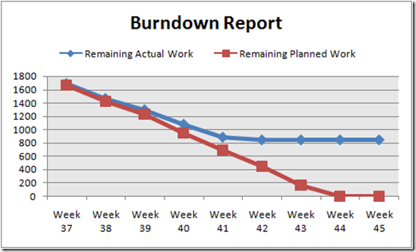

With all these features, you can build a custom report that addresses all the needs of your team. Once you have all the information you’d like to present on hand, the only thing you have to do is pull up the reporting interface, choose the parameters you wish to include, and you’re done!

**5) Resource Management**

Microsoft Project offers project managers a great deal of flexibility when it comes to managing project resources and availability. The resources for a project could be monetary (such as the allocated budget), the people involved (team members), meeting and work rooms, raw materials, and much more. Obviously, a project is going to come with certain limitations on the number of resources that can be used. Microsoft Project’s resource management tools help you track and monitor all available resources and the potential ways in which they can be used for your project(s). The project management tool also lets you assign costs to individual resources, allowing you to later analyze whether certain valuable resources are being overused, underused, and so on.

Every project is unique and has its own resource requirements. This tool allows you to properly assign and order your tasks based on resource availability and demand, with the added option of committing specific resources full time or part time, as needed. With this facility, you can also create a pool of resources and tap into them to complete tasks as your project comes together.

**6) Multiple Projects**

Microsoft Project also allows project managers to work on multiple projects on the same platform, making it easier to deal with different projects in the same company or team. This is defined by the Master Project Plan. Basically, when you’re working with many different project plans, you can combine all of them to form one master plan to use as you move forward. This proves extremely beneficial to project managers, especially if they are juggling multiple projects at once.

Every aspect of a single project tool can be customized to form a master project, be it resource allocation, project planning, or progress tracking. Even reporting is made easy with the help of multiple dashboards. This can be put to good use during meetings and presentations.

**7) Different Views**

Microsoft Project is quite a unique project management tool in that it offers a number of different views. For instance, you can make use of a Gantt Chart, a resource usage chart, a calendar, and much more. Essentially, it allows a manager to view the project from different perspectives and representations, all from one platform. But the best aspect about this feature is that all of these views can be customized together according to the project requirements and combined to form one big project plan.

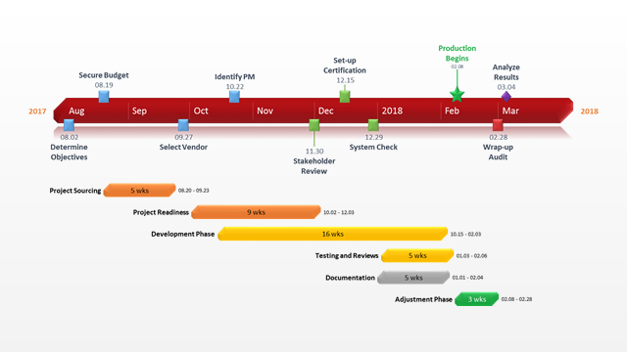

Microsoft Project features many more tools, all of which are geared toward project management. With its set of planning, scheduling, resource allocation, progress tracking, and presentation tools, Project is the ideal package for project managers. This is because it streamlines your projects and helps you stay on track to project success. The program is available in the two forms of Standard and Professional, the latter being the more popular choice.